**Full Stack Java Developer**

Phase-End Project Problem Statement



**Phase-End Project 2**

**Tax Calculation Application**

**Project objective:**

To build a tax calculation application

**Background of the problem statement:**

You, as a full stack developer, have been assigned a project to create an application that can assist users in tax calculations. The application can store and manage the user's asset-related information, track their assets, and calculate the total tax liability for all these assets.

The tasks that need to be performed are as follows:

* Create a specification document detailing the product’s capabilities, appearance, and user interactions
* Document the application flow
* Detail the number and duration of sprints required
* Plan more than two sprints to complete the application
* Set up Git and a GitHub account to store and track enhancements to the prototype
* Implement Java concepts to create this application, including data structures for sorting and searching
* Include the following operations in the application:
* Add a property (a house) and calculate tax after considering factors like locality, the base value of land, the location of the city, the age of construction, and so on
* Add a vehicle and calculate tax after considering factors like registration number, brand of vehicle, cost, maximum velocity, passenger count, vehicle type, and so on
* Calculate the total tax on properties and vehicles
* Provide navigation options for users to switch from the current execution context to the main context
* Include a feature to close the application

**The flow and features of the application:**

* You should include a welcome screen. It should:
* Display the application name and the developer’s details
* Present information about the user interface
* Allow the user to select one of the listed options
* The first option should return a user interface where the user can:
* Add property details to calculate the tax. The required factors for tax calculation include the base value of the land, whether the property is in the city or not, the age of construction, and so on.
* Calculate property tax by using the following formula:

1. If the property is in the main city:

* Property tax = (built-up area × age factor × base value) + (½ × built-up area)

1. If the property is not located in the city:

* Property tax = built-up area × age factor × base value
* Store the details for further operations and save them to temporary storage if the user chooses yes.
* The second option should return a user interface where the user can:
* Add vehicle details to calculate the tax. The required factors for tax calculation include registration number, brand, purchase cost, maximum velocity, capacity (number of seats), type of vehicle (petrol-driven or diesel-driven), and so on.
* Calculate the vehicle tax by using the following formula:

1. Petrol-driven vehicles:

* Vehicle tax = velocity + capacity + 10% of the purchase cost

1. Diesel-driven vehicles:

* Vehicle tax = velocity + capacity + 11% of the purchase cost

1. CNG/LPG-driven vehicles:

* Vehicle tax = velocity + capacity + 12% of the purchase cost
* Store the details for further operations and save them to temporary storage if the user chooses yes.
* The third option should return a user interface where the user can:
* Display the list of properties or vehicles along with their total tax payables.
* Display the total number of properties and the sum of their tax amounts.
* Display the total number of vehicles and the sum of their tax amounts.
* Display the total tax payable amount by adding property tax and vehicle tax.
* Return a message if the list of properties or vehicles is empty (No Data Present at This Moment).
* View an option to navigate back to the main context.
* There should be a fourth option to close the application.
* You should implement the appropriate concepts such as inheritance, interfaces, exceptions, collections, and sorting techniques for source code optimization and increased performance.

**Validation:**

The following validations must be implemented in this application:

* Context menu: Users enter their choice in numeric format to select a specific menu item.
* Property details input and calculations:
* The base value of the land must be input in non-zero and positive number format.
* Property located in the main city: The user must provide a single character input for the property location. Here, *Y* means Yes, *N* means No, and both inputs are

case-insensitive i.e., *Y* and *y* have equal meanings. Other alphabets will be treated as invalid.

* The age of construction is strictly a non-zero positive number.
* Calculated property tax must be displayed in decimal format, up to 2 decimal places.
* Vehicle details input and calculations:
* Registration number: A 4-digit unique registration number in non-zero positive numeric format should be given. A preceding zero also must be considered as a valid part of the registration number. For example, registration number 0010 must be considered valid, while 0000 is considered invalid.
* Brand: The brand of the vehicle must be a text input.
* Purchase cost: The purchase cost must be a non-zero positive numeric value, and it can be between INR 50000 and INR 1000000.
* Maximum velocity: It has a non-zero positive numeric input with a range between 120kmph and 300kmph.
* Capacity (number of seats): It has a non-zero positive number input between 2 to 50.
* Type of vehicle: It must be given as a numeric input, based on the user’s choice between 1 and 3.
* Vehicle tax: The calculated vehicle tax must be displayed in decimal format up to 2 decimal places.

**Business logic/exceptional scenarios:**

* To calculate the tax on property and vehicles, the user must have the property and vehicle details in the database. The student is required to implement the code to handle this scenario.

**The following requirements should be met:**

* To claim the project is completed, the student must get all the tax calculations on property and vehicles in a valid format.
* The student must display the total calculation in a systematic and formatted manner, like a tabular representation.

**Technology Specification:**

The following technologies are used in the development of this application:

* Eclipse or IntelliJ
* Java
* Git
* GitHub
* Scrum
* Search and sort techniques
* Open-source documentation tool (like, Google Docs)

**Screenshots:**

**Task 1: Login**

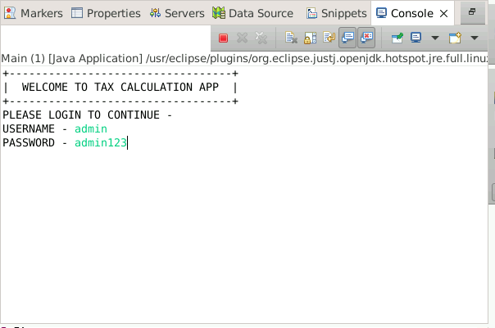

**Task 2: Property tax**

**Task 3: Add property details**

**Task 4: Calculate property tax**

**Task 5: Display all properties**

**Task 6: Vehicle tax**

**Task 7: Add vehicle details**

**Task 8: Calculate vehicle tax**

**Task 9: Display all vehicles**

**Task 10: Total**

**Task 11: Exit**

